|  |
| --- |
| **National University of Modern Languages Islamabad**  **DEPARTMENT OF SOFTWARE ENGINEERING**  **FACULTY OF ENGINEERING & CS**    **Web Engineering**  **Final Project Report**  **Hamza Mehmood**  **Saad Rehman**  **Jibran Naeem**  Submitted to: **Mam Nabeela**  Section: **BSSE-VI (Evening)** |

**INTRODUCTION:**

On-line examinations contents providers to focus on creating effective assessment questions and focusing on exam’s feedback delivery to students. In the paper we present techniques that are pertinent to the elements of assessment process: answers submission, computerized grading, and feedback after submission.

As the modern organizations are automated and computers are working as per the instructions, it becomes essential for the coordination of human beings, commodity and computers in a modern organization.

The administrators, instructor, Students who are attending for online examination can communicate with the system through this projects, thus facilitating effective implementation and monitoring of various activities of Online Examinations like conducting Exams as per scheduled basis and delivering result to that particular use or student. And the details of students who attempted Online Examination are maintained at administrator.

**Objective of the System:**

The objective of the Online Examination Tool is to provide better information for the users of this system for better results for their maintenance in student examination schedule details and grading details

**Functional/Non-Functional Modules:**

1. ADMIN MODULE

2. STUDENT MODULE

**1. ADMIN MODULE:**

1. REGISTER

2. LOGIN

**1. REGISTER**: To be authenticated first have to be registered.

**2. LOGIN:** The Registered User Can be allowed to view inner details for which he

Permitted

**3. STUDENT DETAILS:**

1. REGISTER

2. LOGIN

3. TAKE EXAM- MULTIPLE CHOICE

TRUE/FALSE

4. SEE EXAM RESULTS

5. LOGOUT

1. **REGISTER**: To be authenticated first have to be registered
2. **LOGIN:** The Registered User Can be allowed to view inner details for which he

Permitted

1. **TAKE EXAM-** MULTIPLE CHOICE, TRUE/FALSE: The registered student allowed to start the exam
2. **SEE EXAM RESULTS**: After Completion of exam he can view at his result.
3. **LOGOUT**: After the process of examination he turned to Logout page.

**DATA FLOW DIAGRAMS**:

1. **Database:**

User registrationn

Take Test

Database

**2. User registration**

**User registration**

view user details

Update user details

Register user

Search for user details

**3. Taking Test**

**Taking Test**

Start Exam

End Exam

View Result

**User Interfaces of the System:**

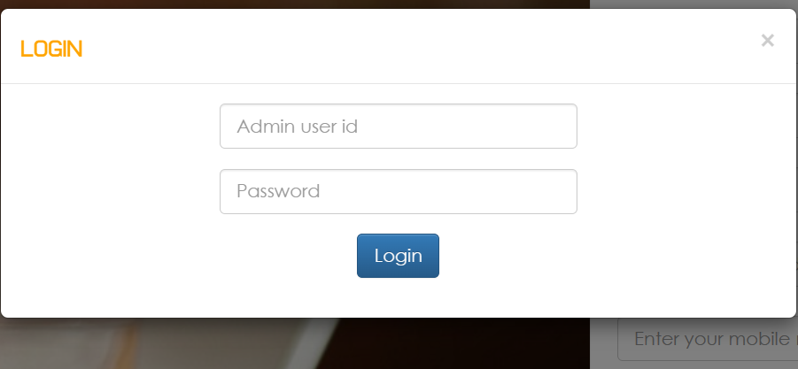

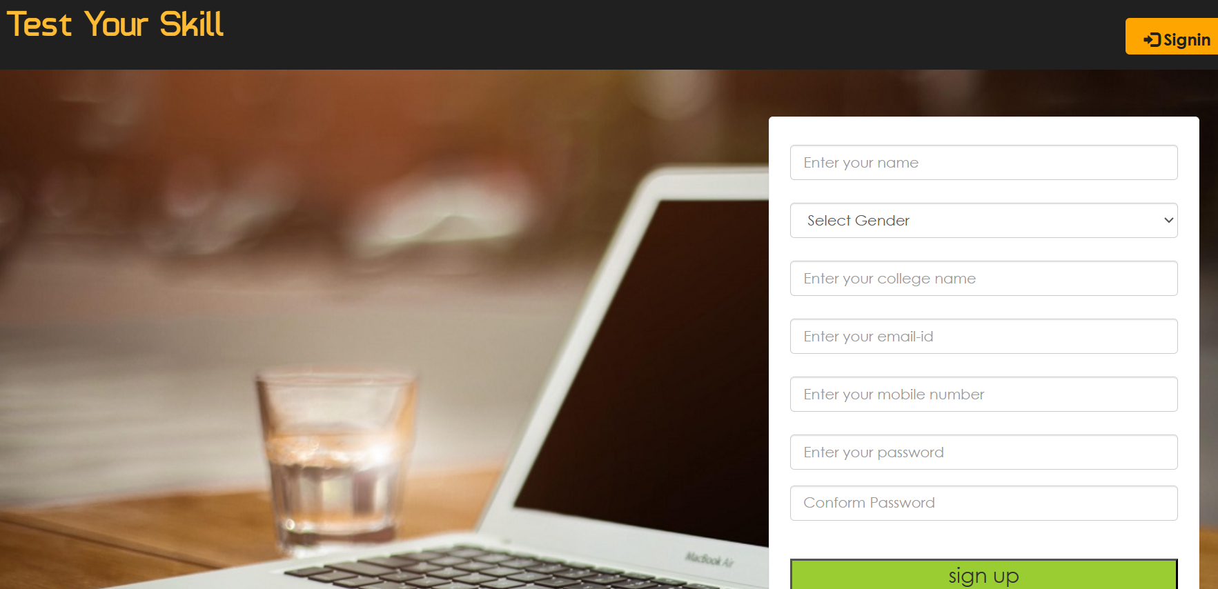

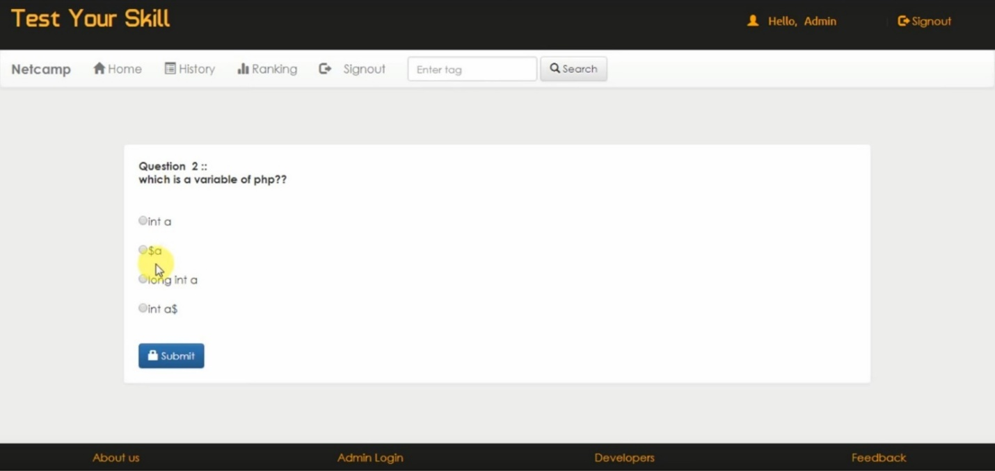

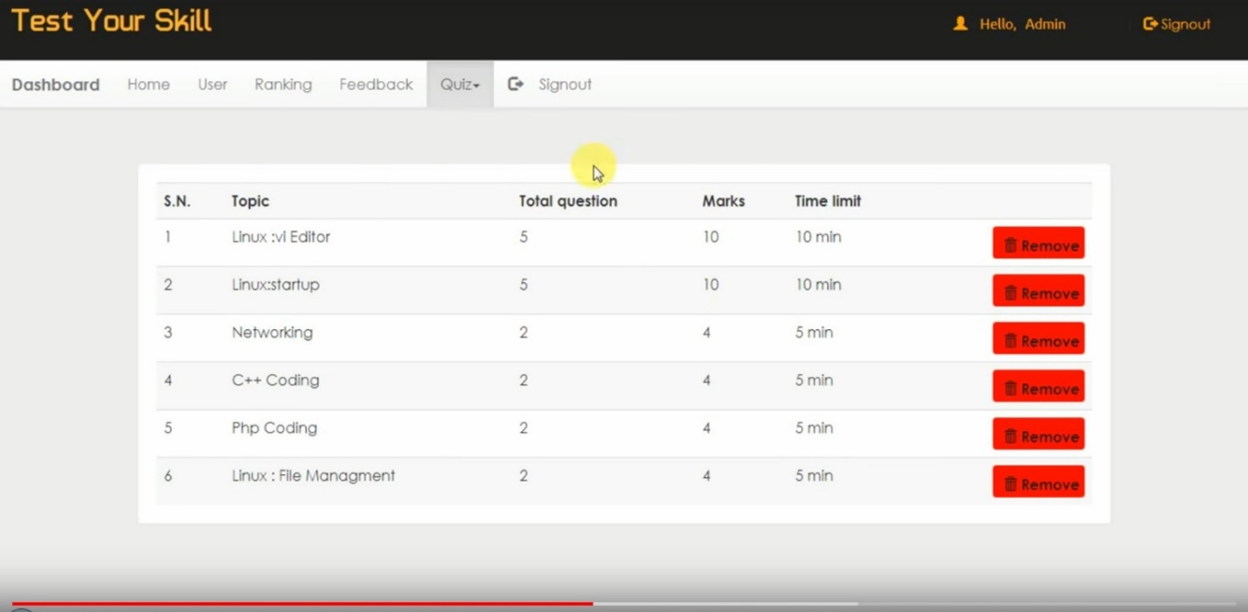

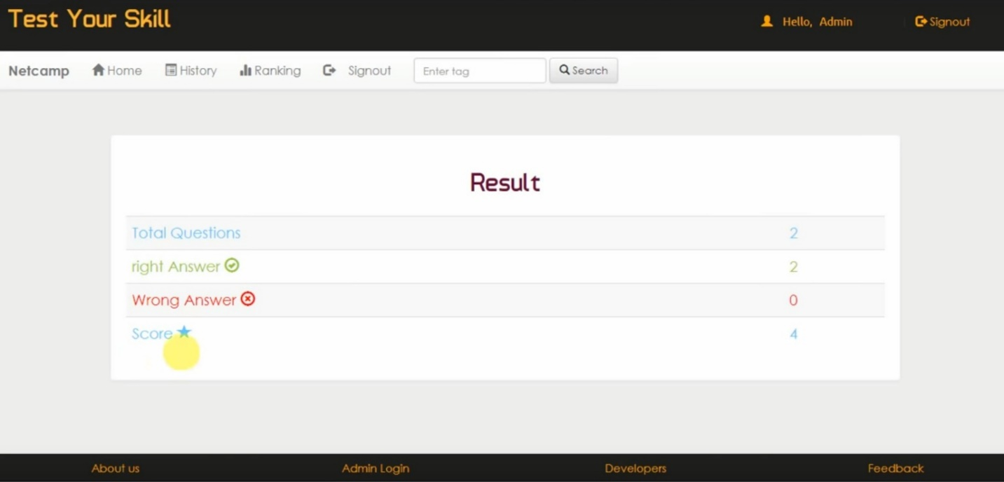

**CONCLUSION:**

The package was designed in such a way that future modifications can be done easily. The following conclusions can be deduced from the development of the project.

* Automation of the entire system improves the efficiency
* It provides a friendly graphical user interface which proves to be better when compared to the existing system.
* It gives appropriate access to the authorized users depending on their permissions.
* It effectively overcomes the delay in communications.
* Updating of information becomes so easier.
* System security, data security and reliability are the striking features.
* The System has adequate scope for modification in future if it is necessary.